**Negative Real Rate Example**

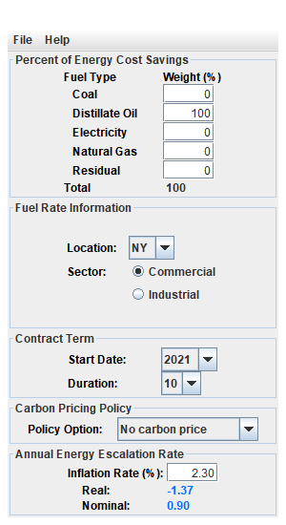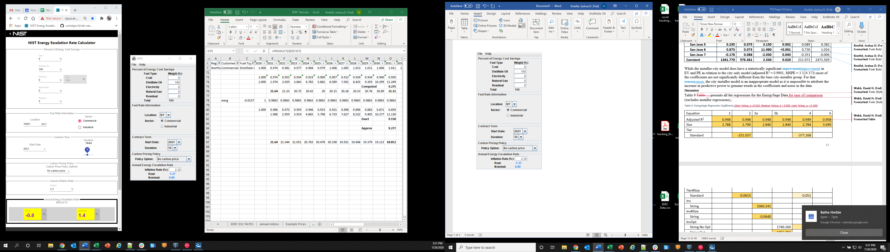

I used the source data for the same example and calculated the values manually in Excel. I created the annual escalation rate shown in Row 7. Row 73 is the product of the annual escalation rates, which is also the ratio of the energy price relative to the base year (2020). The sum of these over the contract length is the computed C = 9.275. I then used the approximation formula to calculated E-avg. This matches that is in EERC-2020 = -1.37% versus your result of -0.8%. I can also recreate the value manually in rows 78-83. I made a mistake in the prior attempt because I was escalating the first year of the contract. Once I set that equal to 1, I matched the results.

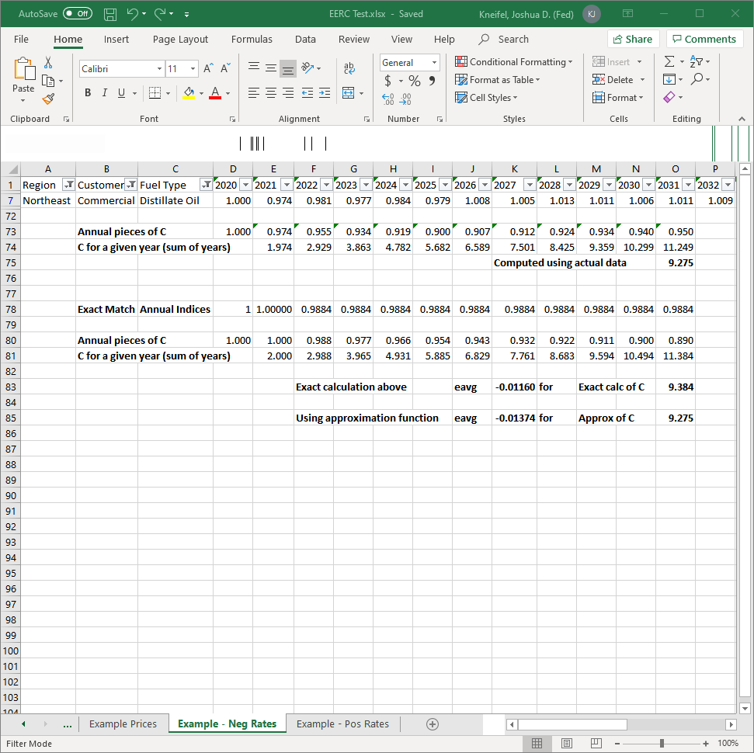

**Positive Real Rate Example**

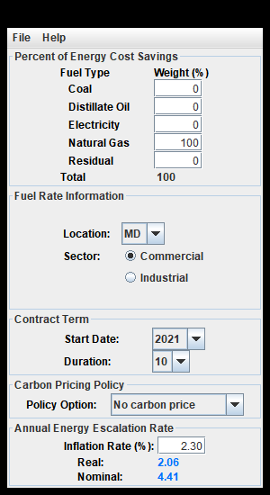 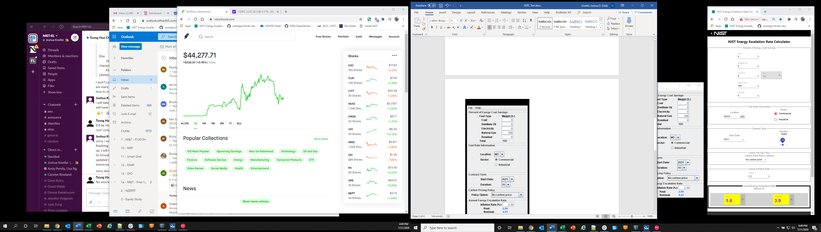

There does not seem to be a flipping of the real and nominal rates. When I calculated C, I was again able to replicate EERC-2020 and match the approximation formula as well as the manual calculation.

